-------------------------------------------------------WEBSITE DEPLOY-------------------------------------------------

**RAISE a request**

(<http://collab.micron.com/is/sites/webcenter/_layouts/15/WopiFrame2.aspx?sourcedoc=/is/sites/webcenter/Secure%20Web%20Environment/How%20to%20Submit%20Web%20Hosting%20Request%20in%20Secure%20Web%20Environment.docx&action=default&DefaultItemOpen=1> )

Target Group: SSD_WARRANTY_SHIP_DATE_WEBCONTACT

Owner Group: SSD_WARRANTY_SHIP_DATE_WEBFORM

*Once the request is approved:*

The hosting of “ssdwarranty” web application in Boise Secure Web environment is completed successfully. Find below the Test and Production web links for the same.

TEST: <http://webtest.micron.com/ssdwarranty/>

PROD: <http://web.micron.com/ssdwarranty/>

Copy all the backend and frontend files to - \\bowebfs01\bowebtest\ssdwarranty\ and perform testing.

Below are the screenshots from the Filer location and the test server:

After the files copied to the filer:

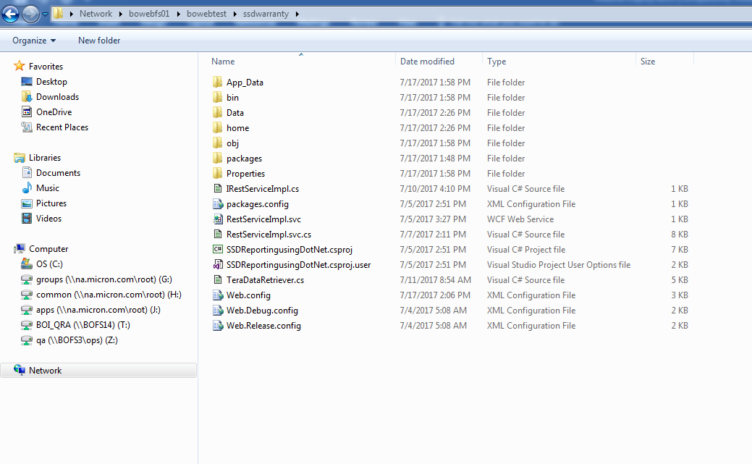

TEST SERVER (once the files are copied to the Filer):

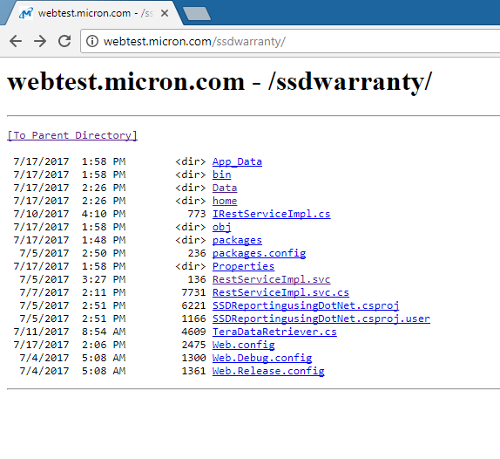

Put ***index.html*** in ‘home’ folder so that once the url <http://webtest.micron.com/ssdwarranty/home/> is accessed, we can see the front end:

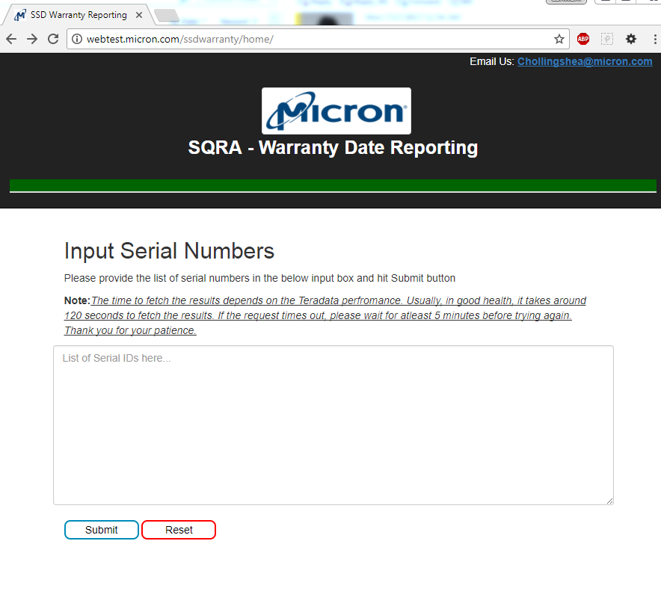

Note: other front end files like images/css/javascript are kept in the folder named – Data on filer.

(so in html file, change the new location of style.css, script.js etc accordingly). Also, in javascript http request, give the correct url of the backend server which in this case would be - <http://webtest.micron.com/ssdwarranty/>